- Introduction:
Project Name: DailyQuote+ – Inspirational Quotes & Sharing Mobile Application

- Objectives:

The DailyQuote+ Mobile Application aims to inspire users by delivering a fresh motivational quote every day, while also allowing them to save their favorite quotes and share them effortlessly. The application focuses on simplicity, offline access, content inspiration, and personalized motivation, ensuring users can stay positive and encouraged throughout their daily routine.

- Target Users:
- Students seeking daily motivation
- Working professionals
- Content creators & writers
- Social media users who like sharing quotes
- Self-improvement enthusiasts
- Individuals struggling with stress or low productivity
- People practicing journaling or mindfulness
- Anyone who enjoys inspirational or philosophical quotes

- System Diagram

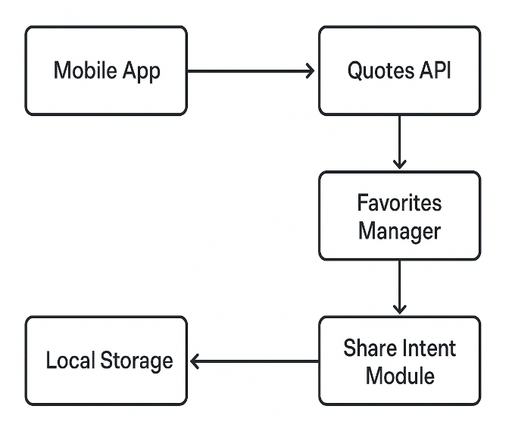

Figure 1: System Design

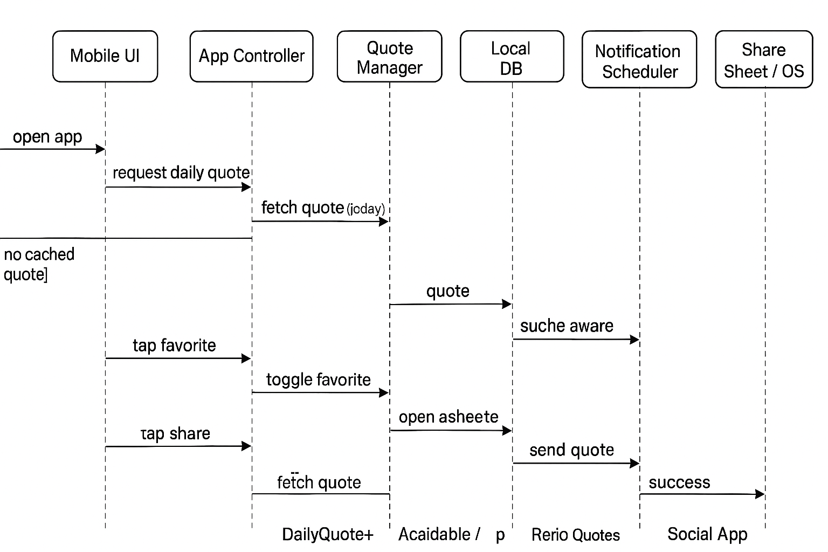
Figure 2: Sequence Diagram

- Sprint Plans:
Add your own treebo or github link

- Sprint:1

During Sprint-1, the core emphasis was placed on setting up the essential app architecture, identifying key features, and designing the minimal UI screens. Initial components such as the Daily Quote Screen, Favorites Screen, and Share Functionality were conceptualized and built using Jetpack Compose.
Core User Stories:
• As a user, I want to see a new quote every day so that I stay motivated.
• As a user, I want to mark quotes as favorites so that I can revisit them anytime.
• As a user, I want to share quotes with others so that I can inspire my friends.
• As a user, I want offline access so I can read my saved quotes even without internet.

UI / UX User Stories
• As a user, I want a clean and minimal UI so that I can focus on the quote without distractions.
• As a user, I want smooth interactions so that reading and saving quotes feels seamless.

System / Developer User Stories
• As a developer, I want to integrate a Quotes API so that the app can fetch fresh quotes daily.
• As a developer, I want to store data locally so users can access favorites offline.

- Sprint: 2

During Sprint-2, the focus was on enabling secure user onboarding and creating the initial navigation flow of the DailyQuote app. This sprint introduced user authentication, access control, and the first interactive screens that appear after login. A functional end-to-end flow—from app launch to reaching the home screen—was completed using Jetpack Compose and Firebase Authentication.
The basic structure for future features (like study plans and progress tracking) was also prepared during this sprint.

Core Features Implemented:
- Splash Screen with branding and smooth transition
- User Authentication Setup (Username/Password)
- Login & Signup Screens built with Jetpack Compose
- Form validation for email passwords
- Navigation flow from Splash → Login → Signup → Home
- Basic Home Screen (placeholder) prepared for future modules
- State handling for login/signup responses and errors

User Stories:
- As a user, I want to sign up with my email so I can create an account in the app.
- As a user, I want to log in quickly so I can access my study dashboard.
- As a user, I want the app to remember my session so I do not need to log in again each time.
- As a user, I want a simple Home Screen after login so I know I have successfully entered the app.

UI / UX User Stories:
- As a user, I want a clean login and signup layout so that the process feels simple and approachable.
- As a user, I want visual feedback during loading so I know the app is processing my login/signup.
- As a user, I want a friendly splash screen so the app feels polished and welcoming.

System / Developer User Stories
- As a developer, I want to integrate Authentication so users can securely log in and create accounts.
- As a developer, I want to manage authentication states so users stay signed in after closing the app.
- As a developer, I want a basic home screen ready for future features like study schedule and progress tracking.
- As a developer, I want reusable UI components so future screens stay consistent.
